Shammah Thao

EEE 174 - CpE 185 Lab Section #2

Monday & Wednesday

Lab 3: Raspberry Pi

Dahlquist

**PART 1: Raspberry Pi Setup**

For this lab, we had to make use of the raspberry pi. We first had to set it up on part 1, including all the installation and updating. We used this linked to help install the raspberry pi : <https://www.raspberrypi.org/learning/hardware-guide/>

**PART 2: Python on Raspberry Pi**

For this part we started using the raspberry pi terminal to create our own file ana write code in it like putty on window.

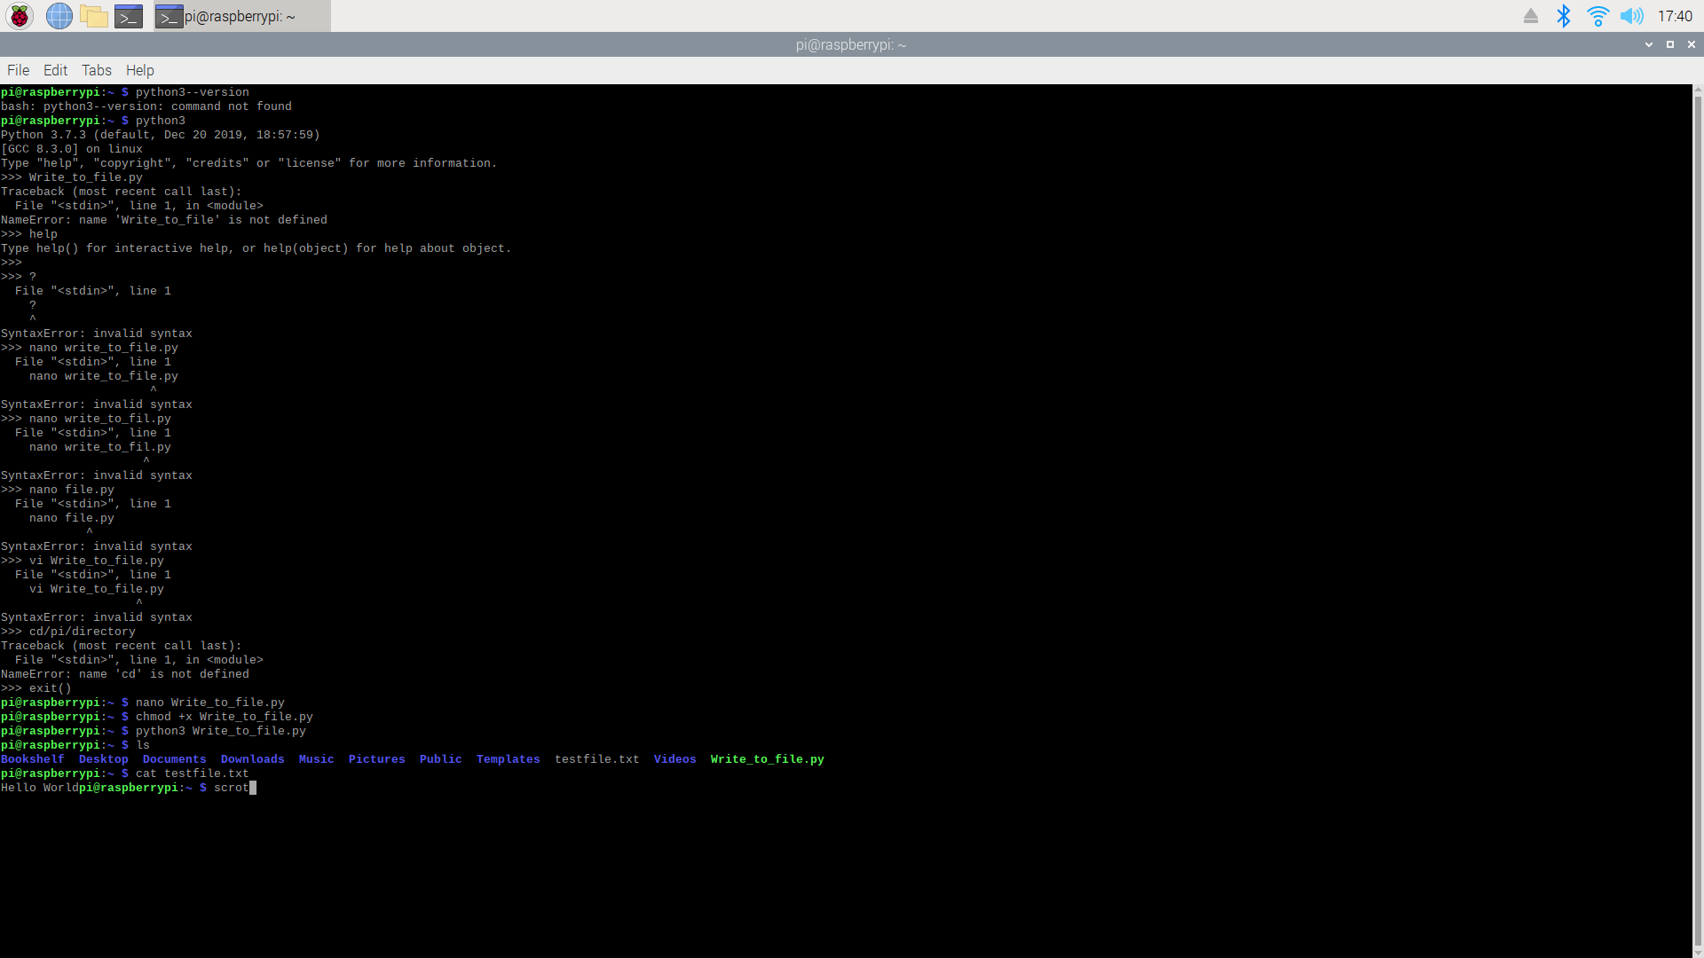

To start off we make a file called Write_to_file.py which contain a python coding of hello world.

Which was then outputted using cat testfile.txt.

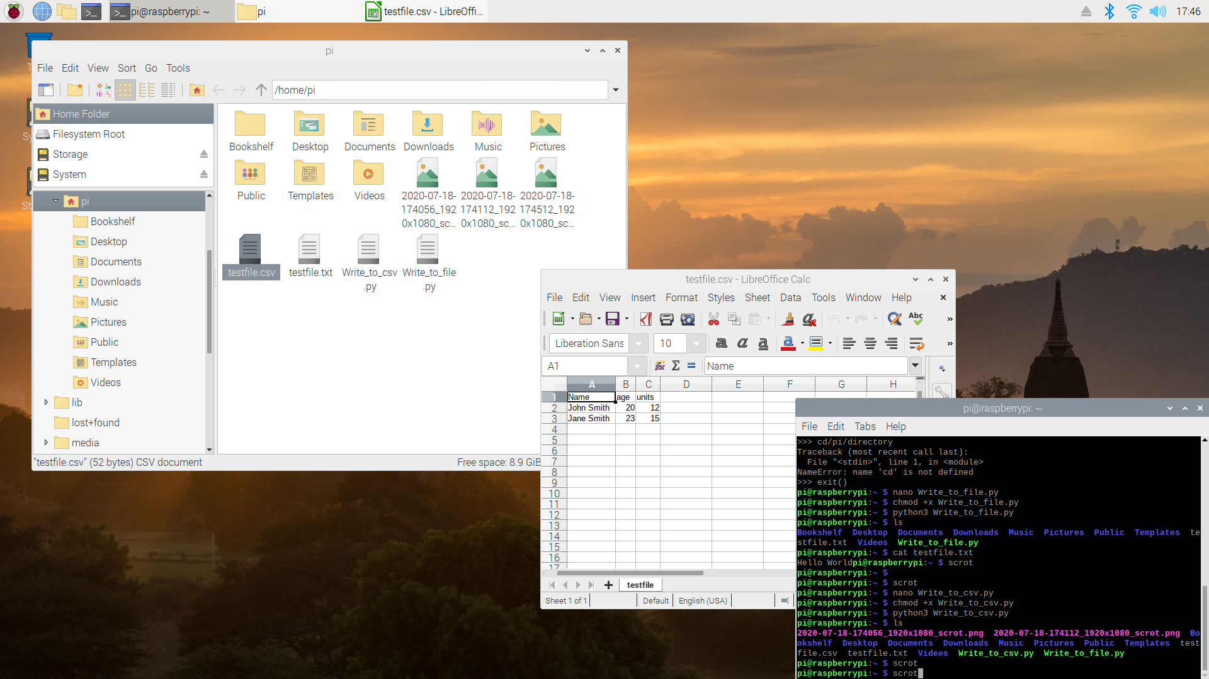

Next, we wrote a CSV file which was then make it possible to transfer information on a the python file to a excel file.

**PART 3: WRITING A C/C++ PROGRAM FOR RASPBERRY PI**

This part, we wrote basic C language into the raspberry pi terminal.

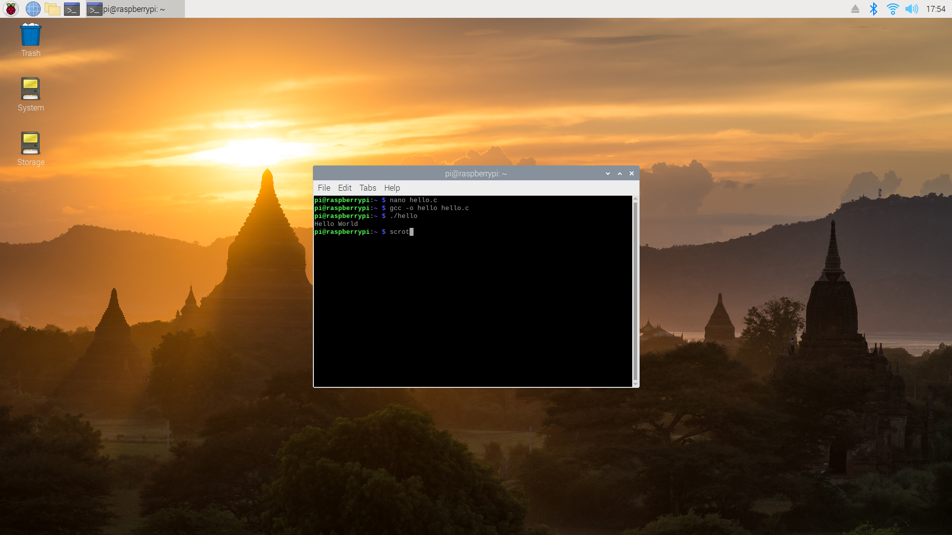

We made a hello.c file which contain C language, which will print out Hello World.

**Part 4: USE GPIO FOR RASPBERRY PI**

For this part we had to set up a led circuit and push button circuit on the beard board and connected it to the pi to power it. Using C coding we create the GPIO test file which will power the pin to light up the led.

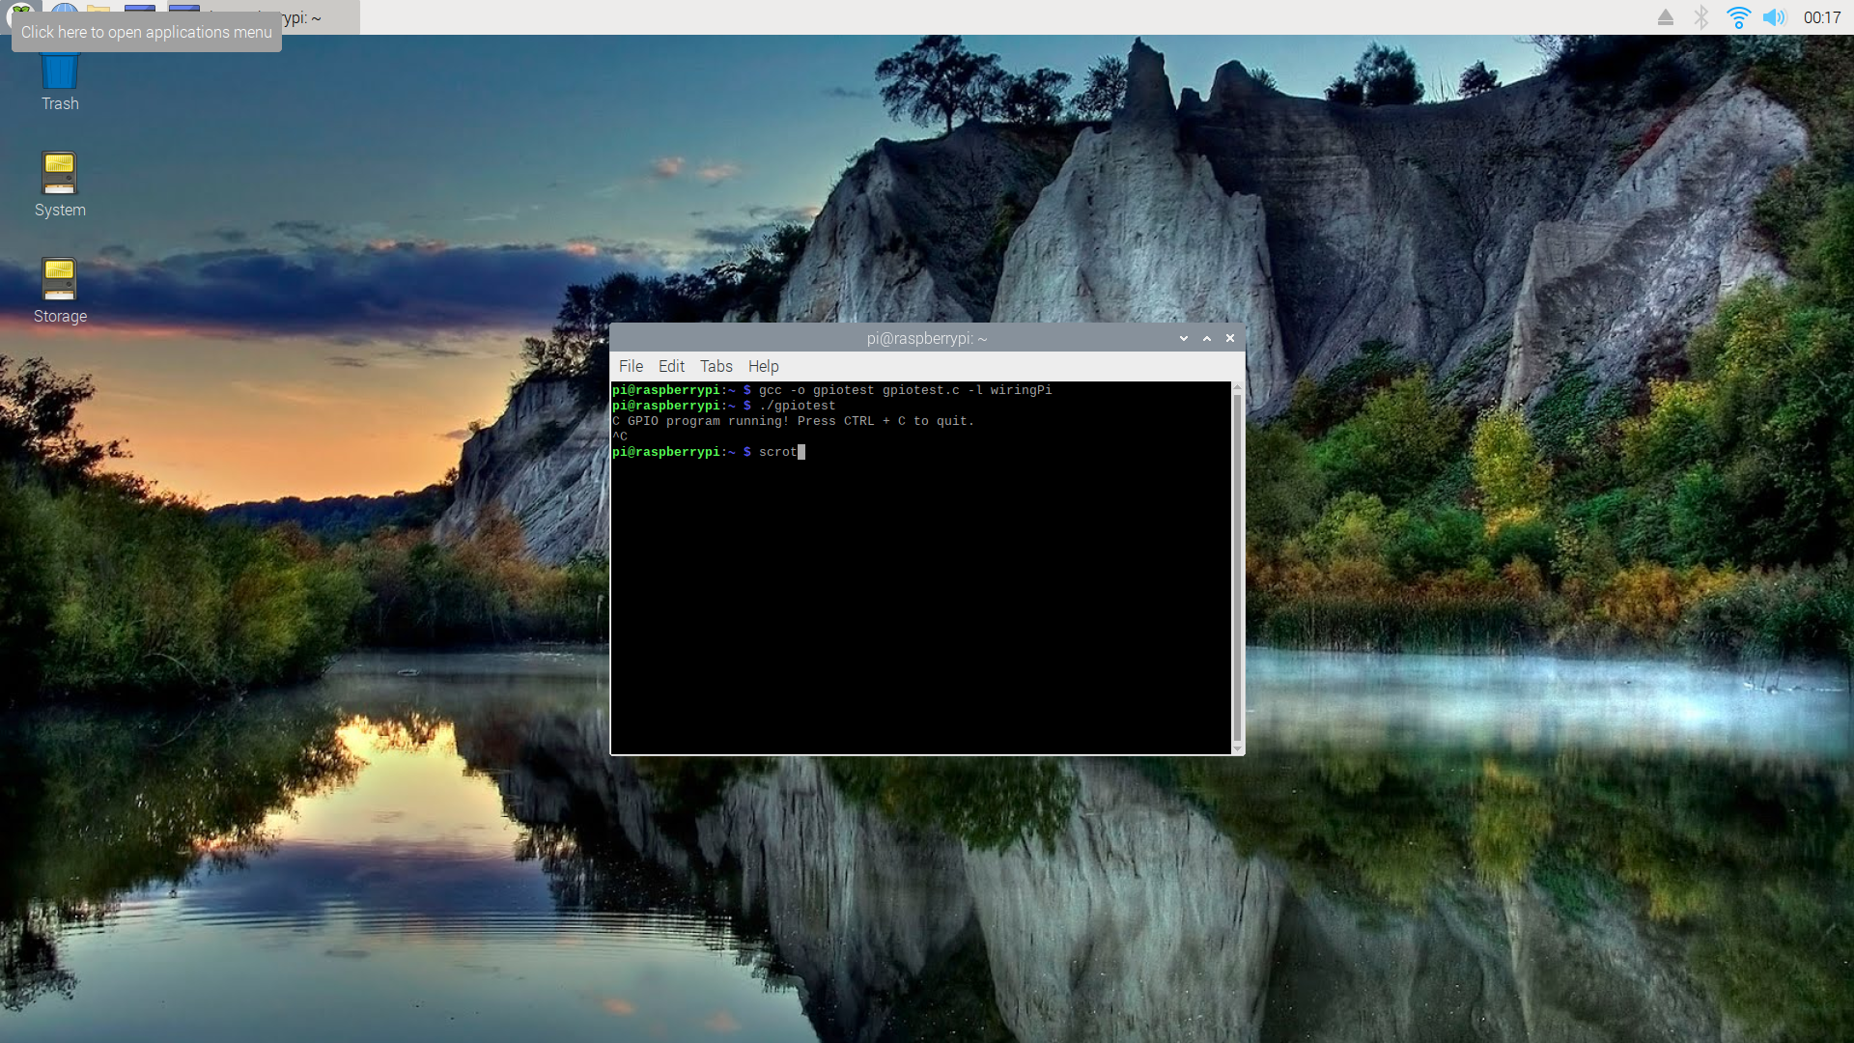

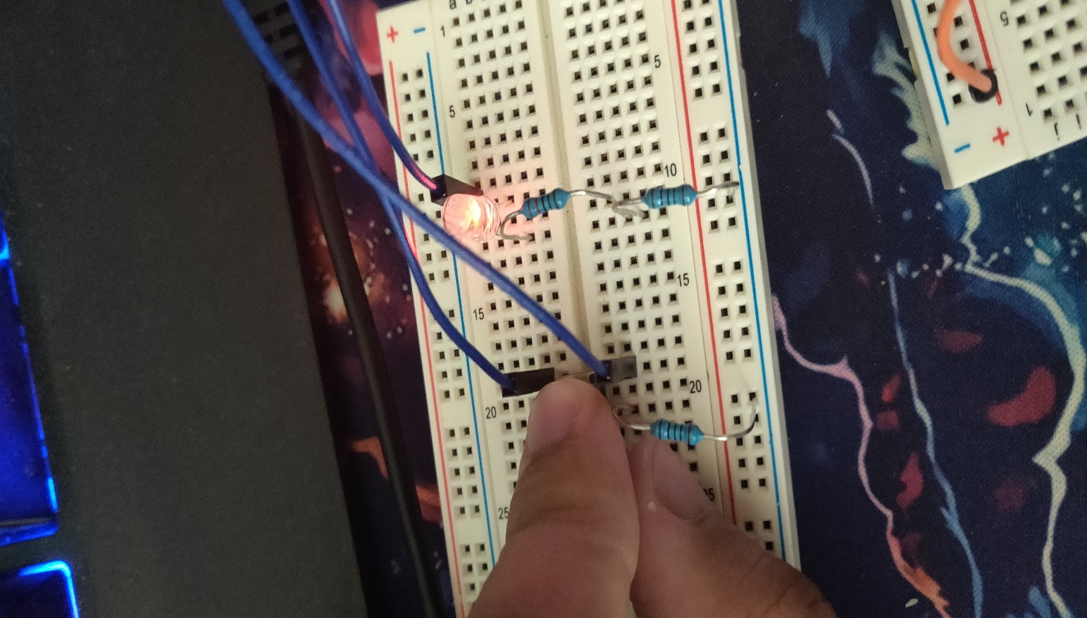

**PART 5: WEB SERVER**

For the webserver, we used python to connect to a webpage and display our message. We made a python file with the python code given to use. We then ran the program to give us the display that we wanted from the webpage: <http://0.0.0.0:5000/> .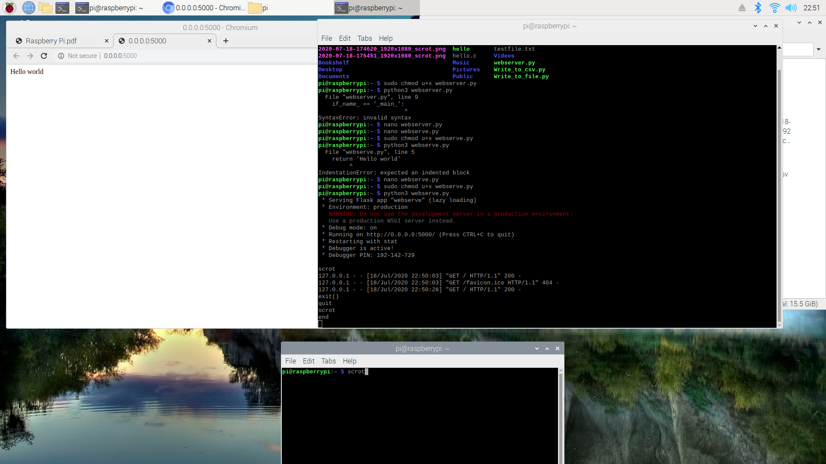

**PART 6: PROJECT**

For the project, I made a quick reaction game. This game involves two people and who ever click on the light first after the light die would be the winner. The game involves the use of the gpio pin along with python codes that would assign the pins with its function.

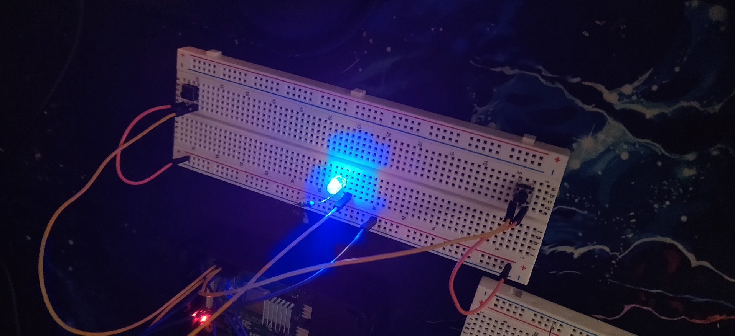

**CONCLUSION:**

This lab was useful in learning how to use the raspberry pi in different kind of coding situation. The raspberry pi come with many feature and application that would help people improve their programming skills. The raspberry pi could be used for a lot of different projects that could be cool. Overall, this lab was pretty good and entertaining.